“Linguistic Concepts as Prototype-Based Categories: Reexamining Allomorphy
Laura A. Janda
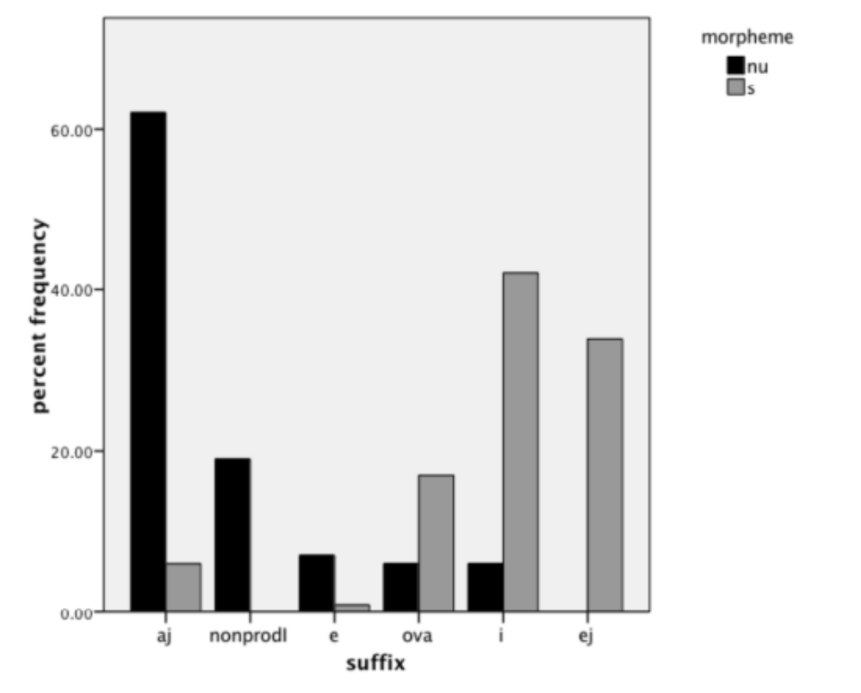
Table 1: Distribution of semelfactive morphemes by verb class

 | base verbs that form -nu- semelfactives |  | base verbs that form s- semelfactives
 | raw frequency | % frequency | raw frequency | % frequency
-aj- | 185 | 62% | 6 | 6%
non-prod I | 56 | 19% | 0 | 0%
*-ě- | 21 | 7% | 1 | 1%
-ova- | 17 | 6% | 18 | 17%
-i- | 17 | 6% | 44 | 42%
*-ěj- | 0 | 0% | 36 | 34%
Totals: | 296 | 100% | 105 | 100%

chi-square = 257.3, with 5 degrees of freedom and p-value < 2.2e-16
Cramer’s V (effect size) = 0.8

Table 2: Semantic classes of base verbs as listed in the Russian National Corpus

 | sound | impact | move | physiol | speech | behav | other
-nu- | 56 | 58 | 80 | 21 | 21 | 3 | 30
s- | 0 | 0 | 15 | 2 | 8 | 7 | 5

This talk summarizes the synchronic findings in this article:
Dickey, Stephen M. and Laura A. Janda. 2009. Xoxotnul, sxitril: The relationship between semelfactives formed with -nu- and s- in Russian. Russian Linguistics 33. 229-248.

Additional References
17 vol dictionary = Akademija Nauk SSSR. 1950–65. Slovar’ sovremennogo russkogo literaturnogo jazyka. Moscow: Izdatel'stvo Akademii nauk SSSR.
Bermel, N.: 1997. Context and the Lexicon in the Development of Russian Aspect. (=Linguistics 129). Berkeley: University of California Press.
Bloomfield, L.: 1935. Language. London.
Böttger, K.: 2004. “Grammaticalization the Derivational Way: The Russian Aspectual Prefixes po-, za-, ot-”, in Bisang, W., N. P. Himmelmann, and B. Wiemer (eds.) What Makes Grammaticalization? A Look From its Fringes and its Components, Mouton de Gruyter, pp. 187-209.
Dickey, S. M.: 2000. “Expressing Ingressivity in Slavic: The Contextually-Conditioned Imperfective Past vs. the Phase Verb stat' and Procedural za-”, Journal of Slavic Linguistics 7(1), 11-44.
Dickey, S. M.: 2003. “‘Semelfactive’ -nǫ- and the Western Aspect Gestalt”, Journal of Slavic Linguistics 10(1), 29-52.
Dickey, S. M.: 2005. “S-/Z- and the Grammaticalization of Slavic Aspect”, Slovene Linguistic Studies 5, 3-55.
Dickey, S. M.: 2007. “A Prototype Account of the Development of Delimitative po- in Russian”, in Divjak, D. and A. Kochańska (eds.), Cognitive Paths into the Slavic Domain, Mouton de Gruyter, pp. 326-71.
Dickey, S. M.: 2008. “Prefixes in the Grammaticalization of Slavic Aspect: Telic s-/z, Delimitative po- and Language Change via Expansion and Reduction”, in Brehmer, B., K. B. Fischer and G. Krumbholz (eds.), Aspekte, Kategorien und Kontakte slavischer Sprachen: Festschrift für Volkmar Lehmann zum 65. Geburtstag, Hamburg: Verlag Dr. Kovač, pp. 96-108.
Dickey, S. M.: Forthcoming. “Common Slavic ‘Indeterminate’ Motion Verbs Were Really Manner-of-Motion Verbs”, in Driagina-Hasko, V. and R. Perelmutter (eds.), Motion Verbs in Slavic, Amsterdam: John Benjamins.
Dickey, S. M. and J. Hutcheson.: 2003. “Delimitative Verbs in Russian, Czech and Slavic”, in Maguire, R. A. and A. Timberlake (eds.), American Contributions to the 13th International Congress of Slavists. Volume 1: Linguistics, Slavica Publishers, pp. 23-36.
Holden, K. T.: 1990. “The functional evolution of aspect in Russian”, in Thelin, N. (ed.,) Verbal aspect in discourse, Amsterdam: John Benjamins, pp. 131-158.
Isačenko, A. V.: 1960. Grammatičeskij stroj russkogo jazyka v sopostavlenii s slovackim. Čast’ vtoraja: morfologija. Bratislava: Izdatel’stvo akademii nauk.
Janda, L. A.: 2007. “Aspectual clusters of Russian verbs”, Studies in Language 31(3), 607-648.
Janda, L. A.: 2008a. “Metonymy via Perfectivization of Russian Verbs”. Slavica Helsingiensia 35 (= S ljubov’ju k slovu. Festschrift in Honour of Professor Arto Mustajoki on the Occasion of his 60th Birthday), 77-85.
Janda, L. A.: 2008b. “Motion Verbs and the Development of Aspect in Russian”, Scando-Slavica 54, 179-197.
Janda, L. A.: 2008c. “Semantic Motivations for Aspectual Clusters of Russian Verbs”, in Bethin, C. Y. (ed.), American Contributions to the 14th International Congress of Slavists, Ohrid, September 2008, Bloomington, IN: Slavica Publishers, pp. 181-196.
Janda, L. A.: Forthcoming a. “Prefixed Perfectives from Non-Determined Motion Verbs in Russian”, in Driagina-Hasko, V. and R. Perelmutter (eds.), Motion Verbs in Slavic, Amsterdam: John Benjamins.
Janda, L. A.: Forthcoming b. “Totally normal chaos: The aspectual behavior of Russian motion verbs”, Harvard Ukrainian Studies 28.
Janda, L. A. and J. J. Korba.: 2008. “Beyond the pair: Aspectual clusters for learners of Russian”, Slavic and East European Journal 52(2), 254-270.
King, B. M. and E. W. Minium.: 2008. Statistical Reasoning in the Behavioral Sciences (5th edition). Hoboken, New Jersey: John Wiley & Sons.
Makarova, A. and L. A. Janda.: Forthcoming. “Single Act Perfectives: The aspectual relationships of Russian -nu- semelfactives”.
Maslov, J. S.: 1948. “Vid i lekičeskoe značenie glagola v russkom jazyke”, in Izvestija Akademii nauk SSSR: Otdelenie literatury i jazyka 7(4), 303–316.
Matthews, P. H. 1974. Morphology. Cambridge: Cambridge University Press.
MSDJa = Sreznevskij, I. I. (1958) Materialy dlja slovarja drevnerusskogo jazyka po pis’mennym pamjatnikam. Moscow: Gosudarstvennoe izdatel'stvo inostrannyx i nacional’nyx slovarej.
Nesset, T. and L. A. Janda.: Forthcoming. “Paradigm structure: evidence from Russian suffix shift”.
Nikiforov, S. D.: 1952. Glagol: Ego kategorii i formy v russkoj pis’mennosti vtoroj poloviny XVI veka. Moscow: Izdatel’stvo AN SSSR.
Nørgård-Sørensen, J.: 1997. “Tense, aspect and verbal derivation in the language of the Novgorod birch bark letters”, Russian Linguistics 21, 1-21.
Rakhilina, E.: 2004. “There and back: the case of Russian go” in Janda, L. A. and T. Nesset (eds.), Times and Cases: A View of Slavic Conceptualizations. Published as Glossos 5 at http://www.seelrc.org/glossos/. 33pp.
RBS = Ja. Kalas, K. Krapiva and P. Glebka, eds. 1993 Russko-belorusskij slovar’. 4th edition. Minsk: Belaruskaja èncyklapedyja.
RUS = K. Bilodid, et al., eds. 1968. Russko-ukrainskij slovar’. Kiev: Naukova dumka.
Rutkowska, M.: 1981. Nie znane polszczyźnie rosyjskie prefigowane derywate odczasownikowe z elementem -sja typu doležat'sja, priest'sja. Wrocław: Komitet Słowianoznawstwa. (= Komitet Słowianoznawstwa, Monografie Sławistyczne 43).
Schuyt, R.: 1990. The Morphology of Slavic Verbal Aspect: A Descriptive and Historical Study. Amsterdam/Atlanta: Rodopi.
Shull, S. :2003. The Experience of Space: The Privileged Role of Spatial Prefixation in Czech and Russian. Munich: Kubon & Sagner.
Sigalov, P. S.: 1963. “Glagoly s suffiksom -anú- (-onú-) v russkom jazyke” , Učenye zapiski Leningradskogo gosudarstvennogo universiteta 322 (Serija filologičeskix nauk, vypusk 68), 64-79.
Sigalov, P. S.: 1975 “Istorija russkix ograničitel’nyx glagolov”, Trudy po russkoj i slavjanskoj filologii: Serija lingvističeskaja 24, 141-181.
Słoński, S.: 1937. Funkcje prefiksów werbalnych w języku starosłowiańskim (starobułgarskim). Warsaw: Nakład Towarzystwa Naukowego Warszaswkiego.
SRJa XI–XVII = Bogatova, et al., eds. 1996-2002. Slovar’ russkogo jazyka XI ~ XVII vv. Vypuski 23–26. Moscow: Nauka.
Švedova, N. Ju. et al.: 1980. Russkaja grammatika vol. I. Moscow: Akademija nauk SSSR.
VTSSUM = V. T. Busel, eds. 2005. Velykyj tlumačnyj slownik sučasnoji ukrajin’skoji movy. Kiev: Perun.
Xlebnikova-Prokopovič, E. N.: 1956. “Glagol’noe formoobrazovanie pri pomošči pristavok v pamjatnikax russkoj pis’mennosti vtoroj poloviny VXII veka”, Doklady i soobščenija Instituta jazykoznanija AN SSSR 10, 130-155.
Zaliznjak, A. A.: 1980. Grammatičeskij slovar’ russkogo jazyka. Moscow: Russkij jazyk.
Zaliznjak, A. A. and A. D. Šmelev.: 2000. Vvedenie v russkuju aspektologiju. Moscow: Jazyki russkoj kul’tury

